Environment Setup
Before running the application, you must set up a Python environment using Miniconda to manage dependencies.
- Install Miniconda: Download and install Miniconda from the official Anaconda website.
- Open Anaconda Prompt: After installation, search for Anaconda Prompt in your Windows search bar and open it.
search in your window system open the anaconda prompt
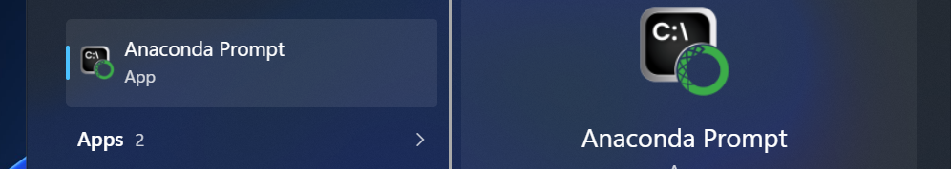
- Create a Virtual Environment: Use the following command to create a dedicated environment named rag using Python 3.10.19:
- Activate the Environment:
Install System Prerequisites ( Visual Studio Build Tools )
Some Python libraries require C++ build tools to compile correctly during installation.
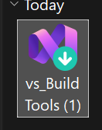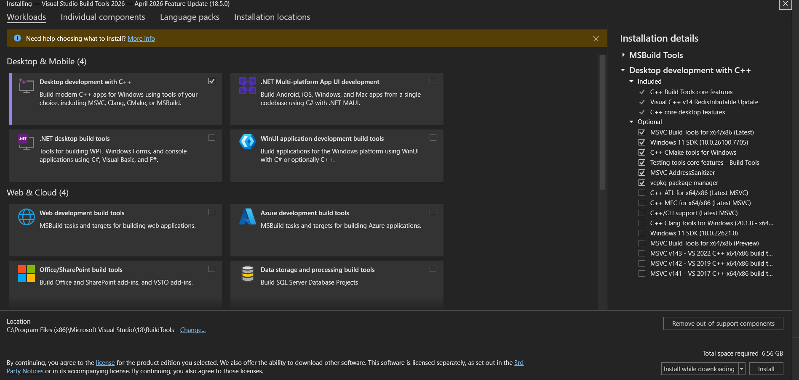

Select Workloads: In the installer, ensure that Desktop development with C++ is checked. This provides the necessary MSVC compilers and Windows SDKs.
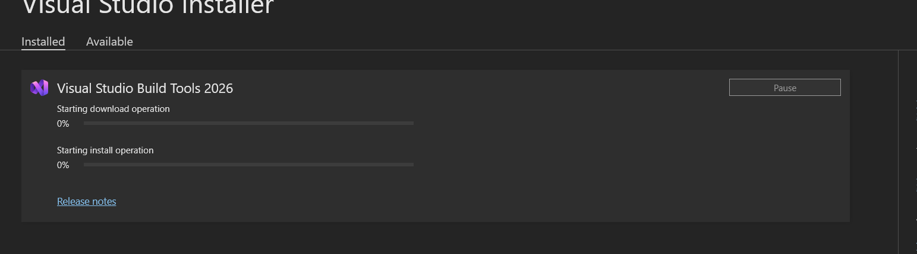Complete Installation: Click Install and wait for the operation to finish before proceeding to the next step.
Dependency Installation
Once the system tools are ready, you can install the project-specific requirements.
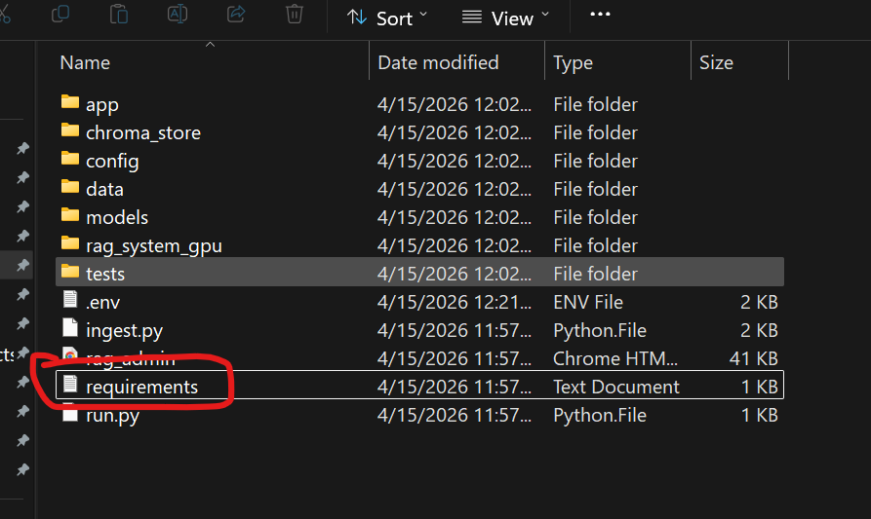
Locate Requirements: Ensure you are in the project directory (e.g., ...\ChatBot_v1\rag_system) where the requirements.txt file is located.
Install Packages: Run the following command to install all necessary libraries, such as Flask and other LLM dependencies:
With the environment activated and dependencies installed, you can launch the backend RAG system.
- Start the Server: Execute the main run script:
python run.py
- Verify Logs: The terminal will display initialization logs. Note that you may see warnings regarding optional components (like OCR libraries) if they are not specifically required for your current task.

Project Structure Overview
The rag_system directory contains the following key components:
- app/: Core application logic.
- models/: Local LLM or embedding models.
- chroma_store/: Vector database for RAG.
- ingest.py: Script for processing and loading data into the system.
- .env: Configuration file for environment variables and API keys.

